Azure Cloud

**Aim**: - To Administrate and manage Azure Active Directory Identities in the azure portal.

​

# **Administrate and manage Azure Active Directory Identities in the azure portal.**

# Azure Active Directory (Azure AD) is a cloud-based identity and access management service. Azure AD enables employee’s access external resources, such as Microsoft 365, the Azure portal, and thousands of other SaaS applications. Azure Active Directory also helps to access internal resources like apps on your corporate intranet, and any cloud apps developed for our own organization.

# Role based access control (RBAC) provides fine- grained access management of resources in azure.

1. Create and configure Azure AD users​
2. Create Azure AD groups with assigned and dynamic membership​
3. Create an Azure Active Directory (AD) tenant​
4. Manage Azure AD guest users​
5. Implement Management Groups​
6. Create custom RBAC roles​
7. Assign RBAC roles​

Create an Azure Active Directory (AD) tenant.

Azure Active Directory->manage tenants->create tenant

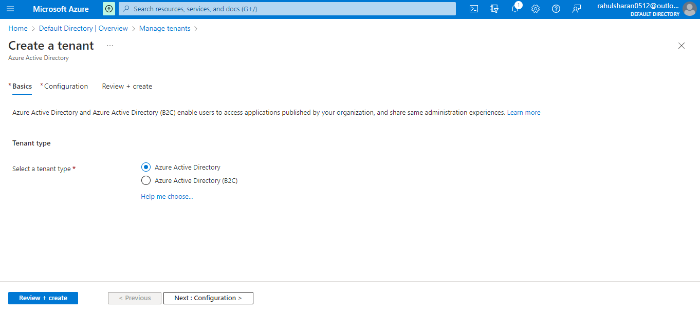

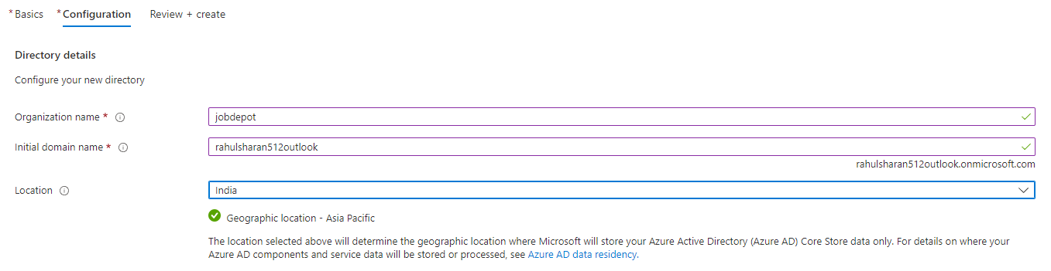

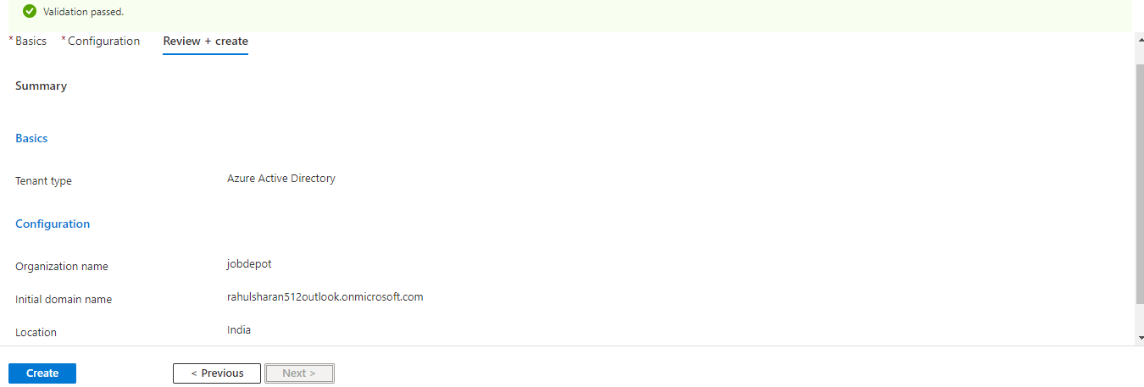

Successfully created an Azure Active Directory (AD) tenant

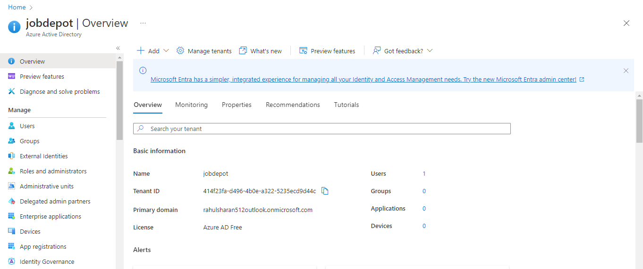

Create a group in azure active directory (AD).

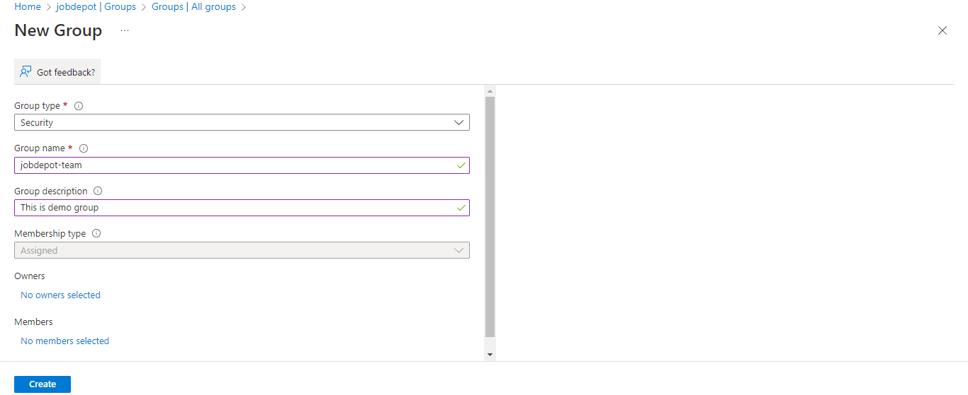

Successfully created group (jobdepot-team).

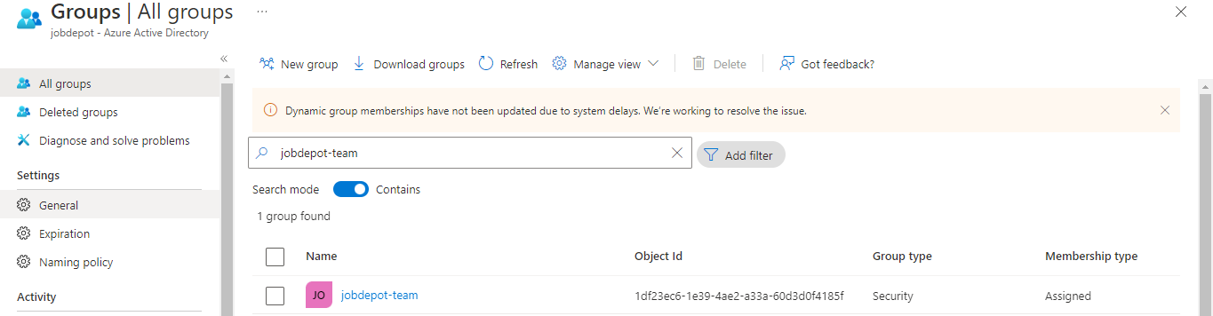

To Add an assignment to user in Global Reader | Assignments.

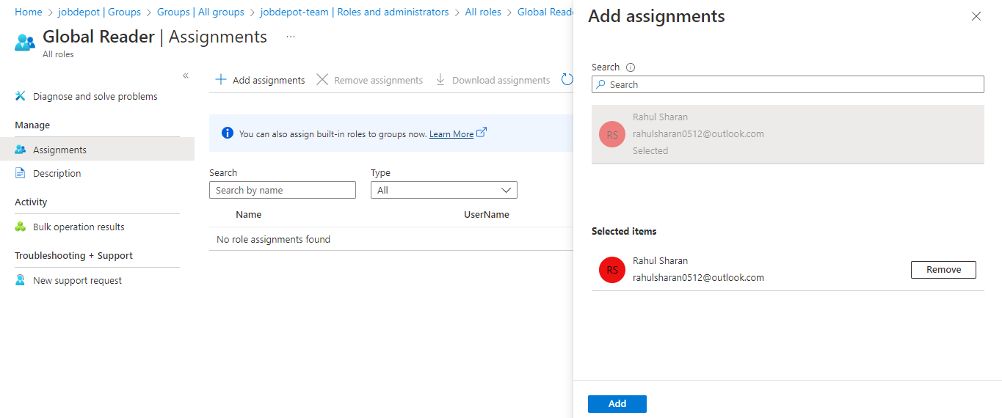

Successfully added assignment.

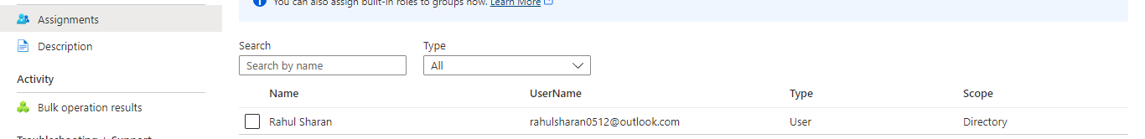

Assigned global reader role to user.

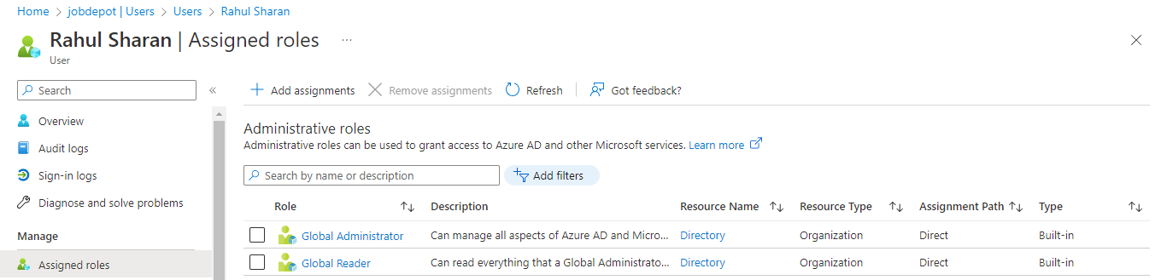

Create and configure Azure AD users.

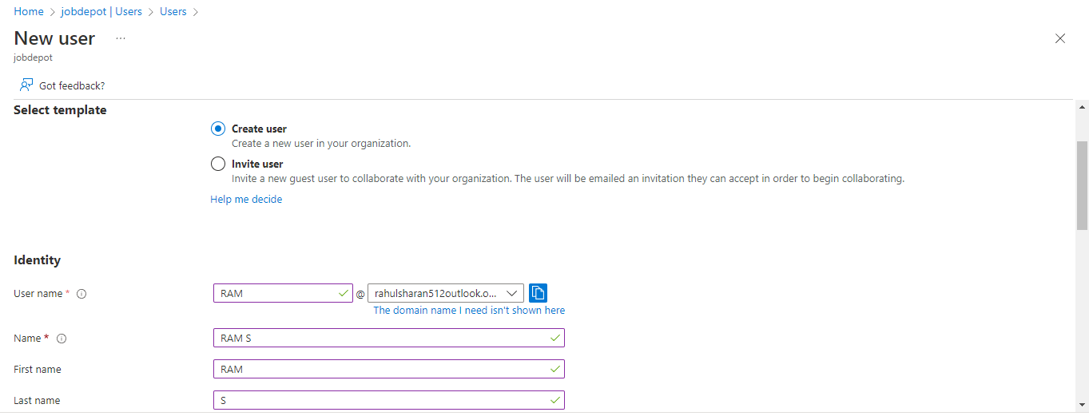

Successfully created user.

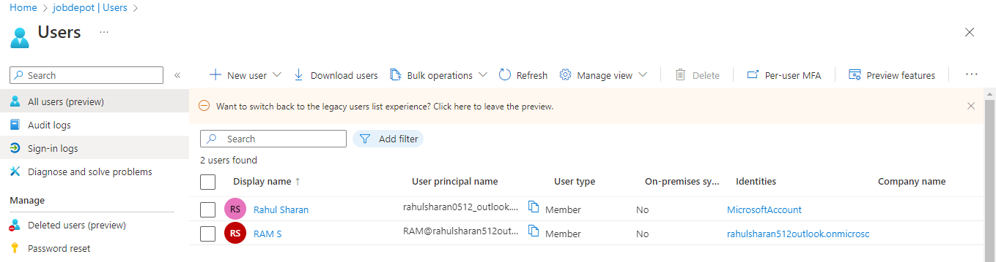

Add members in groups (jobdepot-team).

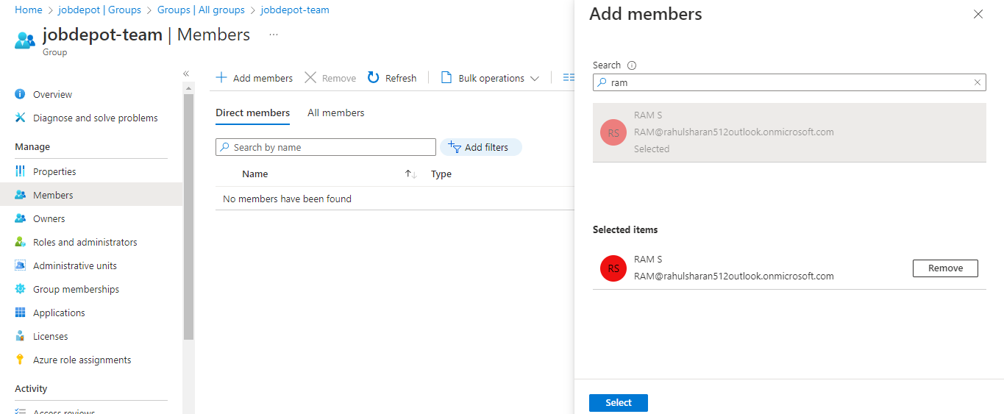

Member successfully added in group.

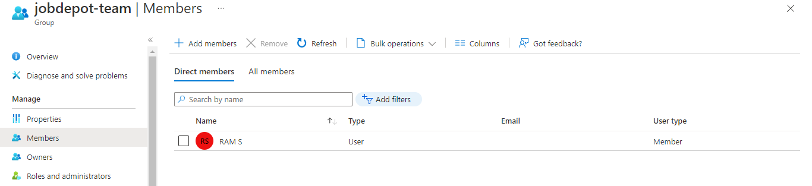

Self Service password reset option for users in AAD.

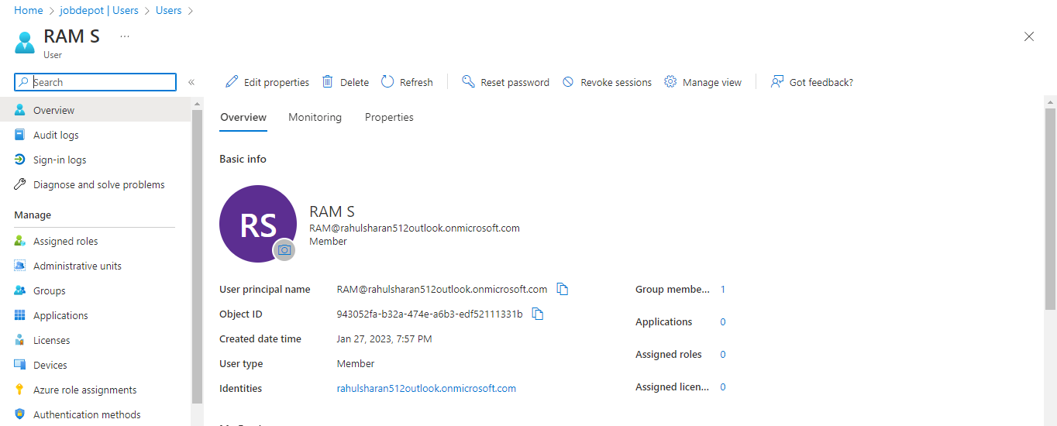

Bulk Create an Azure AD users.

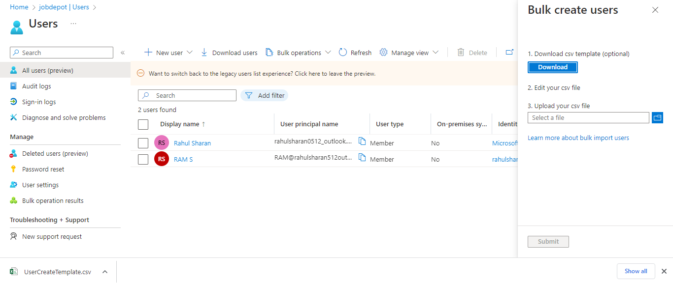

Add role assignment (Virtual machine contributor) on Resource group.

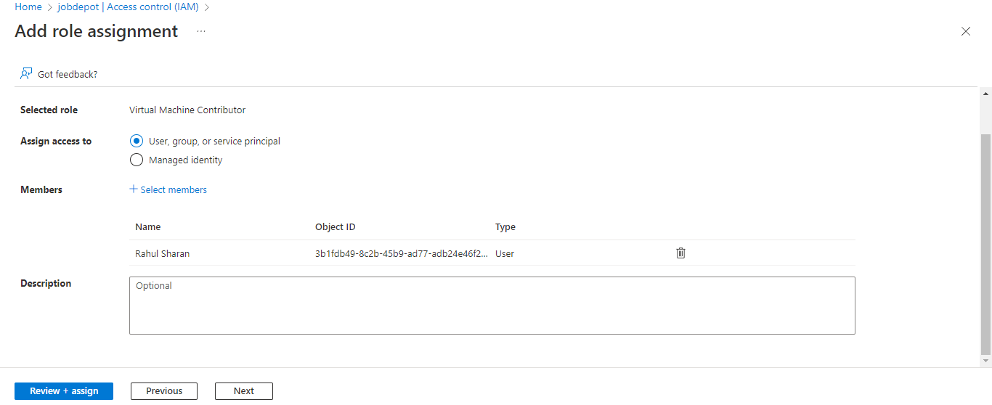

Successfully added as Virtual Machine Contributor for jobdepot.

